Going to the audiology department



You are going to the hospital to get your ears checked.



Your *mum/dad/guardian* will go with you.

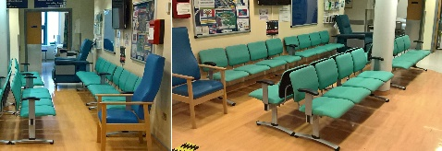

You will have a seat in the waiting room.

The audiologist will call your name

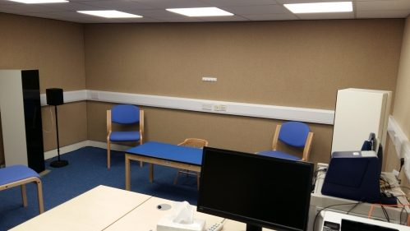

You will then go into a special room to play some games.



You will have a seat at a table and play some listening games with the audiologist.



You can try on our headphones if you like.

The audiologist will ask your *mummy/daddy/guardian* some questions.

The audiologist would like to take a look in your ears with a special light. This might tickle a little.



You will get a sticker for being a very good boy/girl.

You will go home with your mummy/daddy/guardian.