hhhhhhh
WESTERN HEALTH & SOCIAL CARE TRUST COMPLIMENTS AND COMPLAINTS ANNUAL REPORT 2024/25

Introduction:

This Annual Report provides information on the compliments and complaints received by the Western Heath and Social Care Trust for the period 1 April 2024 to 31 March 2025.

We are committed to listening and learning from all our Patients and Service Users, particularly, when the care provided may not have been to the standard that we ourselves would expect.

On occasion individuals, or families, may feel dissatisfied with some aspect of their dealings with the Trust and, when this happens, it is important that the issue is dealt with as quickly as possible. We recognise that everyone has a right to make a complaint and we can learn valuable lessons from them – a complaint may well improve the experience for others.

Complaints provide us with lessons to help us learn how to improve our services. Whilst we aim to give the best service to all our patients and service users, we wish to know when things do not go well so that we can take the appropriate remedial action to prevent it happening again.

We also like to know when Service Users have been impressed or pleased with our service. We can use these examples to share best practice amongst our staff. In addition, compliments can help boost morale.

Some Key Facts:

- Serves a population of approximately 300,000
- In a catchment area of over 4,842km² and has approximately 12,000 staff
- 7 hospitals
- 30 day centres
- 8 children’s homes
- 11 health centres and clinics
- Care is provided directly into thousands of people’s homes
FACTS & FIGURES
2024/2025 YEAR

729 Formal Complaints Closed
717 Formal Complaints Processed

99% of formal complaints received acknowledged within 2 working days
6% Complaints reopened which is consistent with 2023/24
2,951 Written compliments received
Compared to 3,072 the previous year

Complaints this year:

During the 2024/25 year a total of 717 Formal Complaints were received by the Trust. This compares with 674 complaints during the previous financial year.

This demonstrates a 6% increase in the number of complaints received during the 2024/25 year in comparison to the 2023/24 year. The number continues to be low considering the range and spread of services Trust staff provide to service users.

Number of Complaints by Financial Year:

What people complained about?

The following graph provides a summary of the Top 5 subjects reported from complaints received during the 2024/25 year. The top 3 reasons why people complained were Quality of Treatment and Care, Communication/Information to Patients and Staff Attitude & Behaviour.
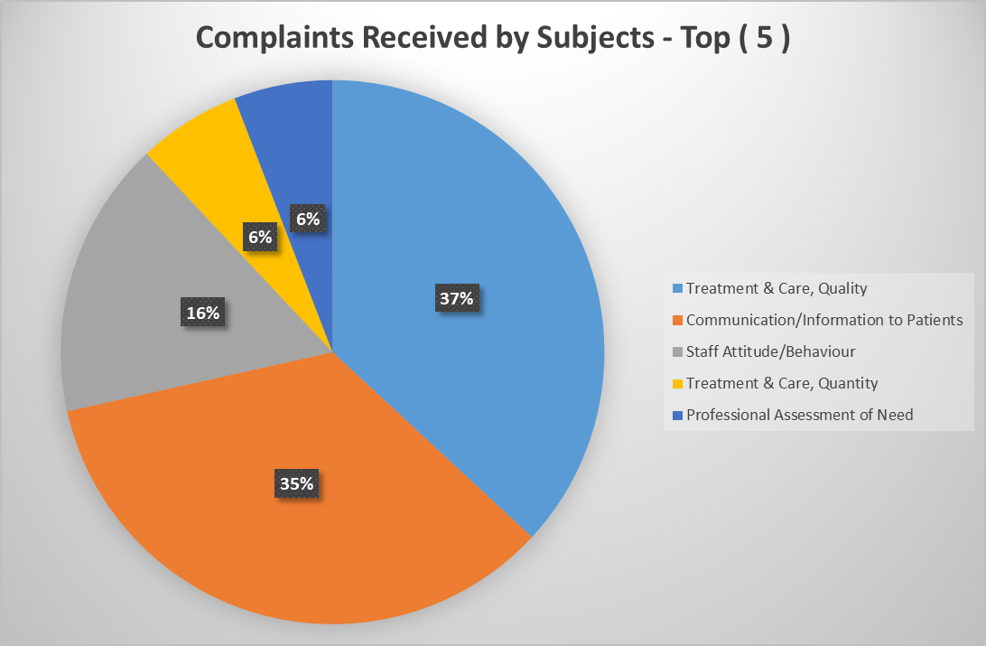

Complaints received by Directorate

This Graph shows the breakdown of the formal complaints received by Directorate for the 2024/24 year:

Complaints resolved during 2024/2025:

During the 2024/25 year, out of the 717 Formal Complaints received, a total of 653 (93%) were resolved. If the complainant was dissatisfied with the Trust’s response a complaint was re-opened if appropriate. The following graph provides a breakdown by month of complaints closed.

Of the 729 closed complaints for the 2024/25 year, 50 were re-opened (7%) which is a decrease compared to the previous 2023/24 year (10.5%).

Reasons for complaints being re-opened:

Informal Complaints:

There are numerous concerns raised by patients, service users and/or their families or next of kin which are resolved at the point of contact with the services. It is acknowledged that informal complaints are under reported and the introduction of the new Model for Complaints Handling Procedure in January 2026 will help provide a more robust process for accurate recording in this area. During 2024/25, 80 Informal complaints were recorded which is a 12% increase on the 2023/24 period. Of these 97% were resolved successfully.

Compliments:


Whilst the Trust recognises that sometimes things go wrong, each year it receives thousands of letters, emails and social media comments of appreciation and expressions of thanks to acknowledge the excellent services provided. In 2024/25 the Trust received 2,951 compliments. We are proud of our staff and ensure that positive feedback is shared and celebrated. Our staff certainly appreciate feedback from their patients and service users, and knowing when things go well.

In line with regional requirements, the Trust has been recording compliments on an electronic online systemsinceFebruary2019. This system provides greater accuracy and consistency in relation to the compliments received in writing and aids to provide statistics on our successes. The system has been designed to be easily located on the Trust’s intranet site. It is fast, user friendly and is able to provide more information on the reasons why people have complemented a service or a staff member. We continue to encourage staff to use this system

Response times to complaints:

Over the 2024/25 year 99% of complaints were acknowledged within the target of 2 working days and 133 complaints (19%) were responded to within the target of 20 working days.

The timeliness of response times to formal complaints has been an ongoing concern throughout the year. Some of the delays can be attributed to receipt of a number of complex complaints – involving in many cases – more than one service area as well as the time and resources required for thorough investigation and development of responses at service level.

The Trust continues to monitor timescales and promotes the need to provide timely responses. Performance measures forbothcompliments and complaints are included in assurance reports to the Chief Executive and quarterly to governance forums at Directorate and Trust level. Whilst the Trust wishes to see improved response times, it places equal, if not more importance on the quality of responses and ensuring resolution for the complainants, relevant to the issues raised.

Monitoring:

The Trust is committed to using complaints/concerns as anopportunityto improve our services and care provided to patients and service users. The Trusts Complaints Department uses a database to record, update, manage and produce reports on complaints activity.

Where there are delays in Investigating Officers providing responses to complaints an escalation process is put into place. Complaintsopenover 3 months are escalated to the Trust’s Chief Executive for attention.

A Rapid Review Group continues to meet weekly to review formal complaints opened on the database the previous week. Brief information is also provided on complaints that have been re-opened and on new complaints received from NIPSO. This meeting provides an early opportunity to review the complexity and grading of complaints and recommends actions to promote a positive and timely outcome. A monthly report by Directorate and Division is also provided to this Group on the number of working days that formal complaints are outstanding. Following the meeting this report is shared with relevant senior staff for action.

Reports are produced regularly for each Directorate’s Governance Committee. These provide information on complaints received, subjects, response times, lessons learned as well as details of outstanding complaints. Quarterly information is also provided on the number of compliments received.

The Trust continues to provide monthly monitoring returns to the Strategic Planning and Performance Group (SPPG) formerly the Health and Social Care Board (HSCB) regarding lessons learned from all complaints closed each month. There continues to be a low percentage of complaints which meets the requirement of the regional guidance to be responded to within the 20 working days timeframe. The Trust recognises that this is one of the key quality indicators for the Trust. This is managed under the Trust’s Medical Directorate Risk Register.

Complaints to Serious Adverse Incidents:

In 2024/25 there were 5 complaints received which resulted in a Serious Adverse Incident (SAI). Upon analysis 20% (1) of these complaints already had an incident recorded, which was under investigation when the complaint was submitted to the Trust. 80% (4) of these complaints triggered an SAI investigation.

Lessons Learned & Service Improvements from Complaints:

The Trust welcomes complaints so that we can learn lessons and improve our service. We use this information to feed back to patients and staff on changes and improvements made.

Complaints are discussed with staff concerned and often the issues are brought to staff meetings and other professional forums for discussion on how services can be improved. Following the investigation of complaints during 2024/25 the following comments were captured as part of the learning:

You said, we did

Complainant said: There was no communication regarding father’s discharge and only found out about this when the Nursing Home informed her that her father had arrived there.

We did: Staff have implemented a system where nursing staff proactively contact families on a daily basis with an update.

.

Complainant said: Complainant raising concerns about the attitude of a staff member when he made contact with the Booking Team.

We did: Staff have reflected on the need to deal with all queries empathetically and sensitively

Complainant said: Complainant raising concerns about the waiting time for her daughter to be assessed by the Autism Service after being referred by her Paediatrician.

We did: acknowledged and apologised for the delay. Provided an assurance that services are now fully operational again and is working to see all who are waiting on assessments. Also directed the complainant to community based services for support. Learning identified - to support young people and their families, the Children's Autism Service has introduced a Clinical Helpline so that families on the waiting list can speak directly to a Specialist Autism Clinician regarding any concerns.

Complainant said: Eye drops that were issued for her granddaughter were already open and had a different name and date of birth on them.

We did: Lessons learned in ensuring medication is opened and checked and any unused medication to be returned to pharmacy.

Complainant said: Complainant’s daughter received a letter stating that she had an appointment to pick up her long awaited cardiac monitor. She immediately phoned the Cardiac Investigations Department and spoke with a staff member who advised her that she had been given a new appointment for a later date. No apology was given to her daughter for the Trust’s’ failure to advise of her new appointment details nor for the additional stress this caused.
.
We did: Arrangements were put in place to ensure the patient’s appointment letter is posted to them with more than 1 week’s notice to appointment time. Process also put in place to contact patients if they do not attend their appointments to try and fill the slot for another patient.

If people are dissatisfied:

Sometimes people are not happy with the outcome of the investigation to their complaint. In the last year 7% of complainants contacted us to tell us they were not completely satisfied with the response provided. We encourage people to let us know if they are unhappy, and we consider other options to attempt to resolve their concerns. We routinely offer to meet complainants, as this allows the opportunity for more detailed discussions, face-to-face.

Northern Ireland Public Services Ombudsman (NIPSO):

For those who remain dissatisfied, they have the right to approach the NIPSO Office directly. The Advice, Support Service and Initial Screening Team (ASSIST) is the public’s first point of contact with the office. Where the ASSIST team decide that they cannot resolve a complaint, the case is forwarded to the Ombudsman’s Investigations Team.

During 2024/25, there were requests for information from the Ombudsman’s office as follows:

- 26 letters of assessment;
- 12 of these were accepted for investigation
- 2 cases have since being closed and 10 are on-going

